Query the list of CITY names starting with vowels (i.e., a, e, i, o, or u) from **STATION**. Your result cannot contain duplicates.

**Input Format**

The **STATION** table is described as follows:

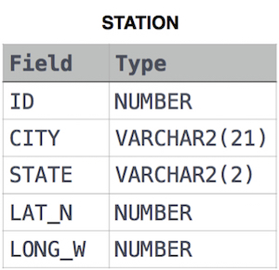

where LAT_N is the northern latitude and LONG_W is the western longitude.

Ans:

select distinct CITY from STATION where

city like 'A%' or

city like 'E%' or

city like 'I%' or

city like 'O%' or

city like 'U%';